NEW PATRIOTIC PARTY
NEW PATRIOTIC PARTY
Headquarters, Private Mail Bag, Accra-North, Ghana
Tel: +233 (0)302 264329 Fax: +233 (0)302 229 048
Email: nppdcom@gmail.com Website: www.thenewpatrioticparty.org

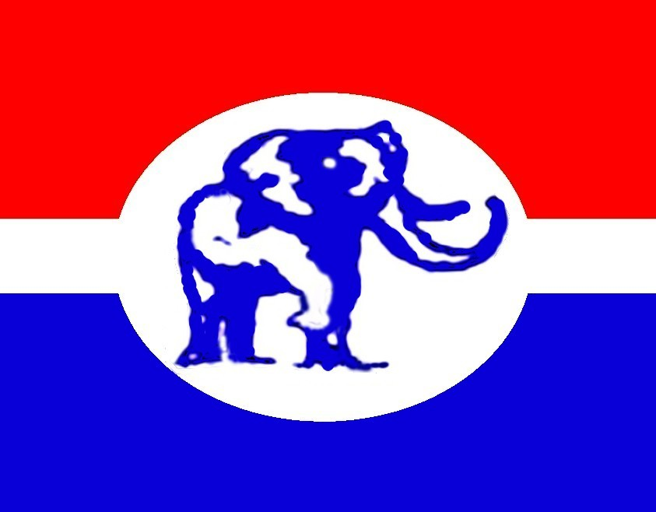

DEVELOPMENT IN FREEDOM

19/4/2015

SPEECH BY NANA ADDO DANKWA AKUFO-ADDO, 2016 PRESIDENTIAL CANDIDATE OF THE NEW PATRIOTIC PARTY, AT THE MEETING OF TESCON, UCC ON SATURDAY 18TH APRIL 2015.

Mr. Chairman, Senior Members of the University of Cape Coast, Mahamudu Bawumia, Regional Secretary, Kwamina Duncan, NPP notables, Invited Guests, Students, I am excited at this opportunity to have a conversation with you, and thank you so much for this warm and tumultuous welcome. I am very, very grateful. Thank you very much indeed. I am excited, not just because you are as they say our future leaders, but because you remind me of the urgency of today, the urgency of now, the now of growing poverty, high cost of living, low income levels, massive unemployment, inadequate educational facilities, inadequate access to health and social services amongst others. The company of young people is doubly reassuring because the exuberance, dynamism and energy of young people is what we need for the quick push that we have to make if we are to catch up with the rest of the world.

In all this, TESCON occupies a special place in the life of our nation, of our party and of myself. This is why I am so happy to speak again on a TESCON platform. 2000, the year of its inauguration, saw TESCON take the lead in mobilizing the youth of our party and of our country to make the historic change of 2000, when, for the first time in Ghanaian history, an opposition party, the NPP, came to power through the ballot box. That event gave a great boost to the consolidation of the principles of democratic accountability in our body politic. TESCON in 2000 acted under its wonderful slogan – commitment without inducement. Is that still your slogan? Are you sure? We need it to make history again, to make another crucial change. TESCON has been very generous to me. It has provided me with my Political Assistant, Francis Asenso-Boakye, its Founding President.

In 2000, I was the main speaker at an event in Independence Hall at the Kwame Nkrumah University of Science and Technology, when TESCON’s outreach programme was launched for the elections of that year. I made three commitments on that occasion. I said that if we won, we would repeal the infamous Criminal Libel Law; we would abolish the notorious cash and carry in our healthcare system; and we would in the next decade take Ghana from a poor to a middle income status. The NPP in power realised each one of these promises. We repealed the Criminal Libel Law. We abolished cash and carry and introduced the National Health Insurance Scheme. And by 2009, when we left office, Ghana was a middle income country.

So I am here again so we can have a conversation, albeit brief. A conversation about our nation. A conversation about our collective future. A conversation about our democracy. You must show an interest in how this nation is run. It is important that you question the use to which the nation’s leaders are putting our money. It is important to question the use to which they are putting your parents’ tax money. Otherwise you run the risk of inheriting a nation that is bankrupt and incapable of meeting your aspirations: aspirations for which you have spent the better part of your life going to school.

Today the darkness that descends on you in the lecture halls in the middle of an exciting lecture is symptomatic of the darkness that has engulfed this nation. When I talk about the darkness that has engulfed this nation, I don’t just mean the literal sense in which we are constantly in the dark. But the sense of hopelessness and despair that has engulfed this nation. But let us not throw up our hands in despair. There is hope. There is light at the end of the tunnel. But we should not just depend on hope to bring this glorious future about. “Heaven helps those who help themselves.” You must show an interest and actively participate in the governance process of our country, if you are to have the Ghana of your aspirations.

Mr. Chairman, Government apologists are saying that after the government resolves the “dumsor” crisis we, as opposition people, will have nothing to talk about. I am astonished by this proposition. The devastation that “dumsor” is wrecking on our nation goes beyond opposition or government talk. It is not a campaign weapon. It borders on the very survival of our country. According to the highly respected Institute of Statistical, Social and Economic Research (ISSER), the cost of “dumsor” for 2014 alone is in excess of 1 billion Ghana cedis. If we consider that this crisis has been going on since 2012, then we are talking about a national loss of some 4 billion cedis. Today, industries are folding up, workers are being retrenched, livelihoods are being lost, people are dying needlessly in our hospitals, our economy is in serious decline, all of which add up to the ravages of poverty and disease. These are not matters about which a nation can recover with the wave of a hand or with the resolution of the crisis of “dumsor.” How does the resolution of the crisis of “dumsor” resurrect the many Ghanaians who have lost their lives in hospitals across the country? How does the resolution of the crisis of “dumsor” restore the livelihoods of the thousands of workers who have lost their jobs? How does the resolution of the crisis of “dumsor” restore the loss of productivity over the past three years? I know of a group of investors who have their factories around the Achimota Brewery, and who manufacture plastic products. They have closed shop and are leaving for Ethiopia. There are many, many such stories. Today, investor confidence in our country is at an all- time low. The 4 billion Ghana cedis that this nation has lost to the crisis of “dumsor” can per the calculation of this government build about 60 senior high schools. Ladies and gentlemen, we are in a crisis. Just a few days ago, the Director General of Ghana Health Services, Dr. Ebenezer Appiah-Denkyira, suggested to health facilities to charge patients an extra amount of money to take care of the cost of “dumsor.” Already the health insurance scheme which the NPP government under President Kufuor introduced has collapsed and to think that we will have to pay extra to take care of “dumsor” is unimaginable. Barclays Bank is creating a new financial product that enables businesses to buy generators. And we are told that the resolution of the crisis at some uncertain date in the future will wipe out the effects of all this.

It is as a result of the deficit of ideas in solving problems like dumsor, coupled with the mismanagement of the economy and a lack of fiscal discipline on the part of the Mahama-led NDC government that has led Ghana to the IMF. For the first time in history, an oil rich country, some five years into oil production, is seeking a bailout from the IMF. It is this government, which has received more money in loans, tax revenues and export receipts than any other government in our history, that has ended us up with our going cap-in-hand to the IMF for assistance. This sad spectacle is an indictment on the kind of leadership we have at the helm of affairs in our country. As our brilliant economist, my right hand man, Mahamudu Bawumia so aptly put it: “an IMF programme does not guarantee fiscal discipline. Only a commitment to fiscal discipline by the government can guarantee it.” The NPP, under the leadership of President John Agyekum Kufuor, showed in 8 years that fiscal discipline and committing the nation’s resources into areas that will improve the lives of Ghanaians are possible. We need to bring back confidence in the economy so that businesses and families can plan their budgets properly. What an Akufo-Addo government will do again is to bring back that confidence. We will ensure fiscal discipline on how taxpayers’ monies are spent and ensure macroeconomic stability. Investors, domestic and foreign, will only be interested in Ghana when they can be assured of the bankability of investing in our economy. We will move away from high budget deficits and reckless borrowing because we know of the benefits of fiscal responsibility – low inflation, reduced interest rates, exchange rate stability, avoiding HIPC and making savings for social and capital expenditure. With discipline and responsible management, we will have the money to restore teacher trainee and nurse trainee allowances.

Another debilitating factor in the management of our public finances so far under this government has been widespread corruption. It has become an even more dangerous factor now that we have oil. Unless we tackle the problem of corruption in government, we run a real risk of cynicism overcoming our politics and, thus, a catastrophic loss of confidence in our democracy. Ghana cannot afford this, our forebears did not struggle for Ghana to end up in such a sad state of affairs, and I believe that we can, in this generation, deliver the economic transformation that has eluded us so far if we do the right thing. Corruption has to be defeated. Corruption on any scale is expensive and has been especially expensive to Ghana’s development under this fourth NDC government. Let me give you a simple example to show you what I mean. The scams involving SADA, GH¢200 million; GYEEDA, GH¢952 million; and questionable judgement debts of GH¢687 million, all together, amount to GH¢1.8 billion. At the exchange rate that was prevailing at the time when the scams took place, we are talking about $1.1 billion. The entire IMF bailout is $912 million. These scams, that I have mentioned, are only a fraction of the numerous scams that you and I know about. Just these three give a loss to our nation which is more than the entire bailout. We, in the NPP, understand that the good people of Ghana are weary of the impact of pervasive corruption on our society and simply want their government to fix the problem. They want it fixed not with words, but action. It is my belief that the fight against corruption must start with an incorruptible President. I have said so before and I will repeat it again today. I can assure you, in all humility, that I am not, have never been and will never be corrupt. I can also assure you that, as your President, I will NOT condone corruption in my Government. I have stated publicly that people who see service in government as an avenue for making money will have no place in my government. Their proper place is in the private sector, where money-making is a positive thing. Public service is exactly that, public service. I bring to the table and to the Office of President of this potentially great country an unblemished track record of personal integrity and fortitude. I invite you to bank on my essential leadership attributes and help make me your president. I will lead a strong fight against corruption in this country.

In my interaction with people from all walks of life, during my time as Member of Parliament, Attorney General, Minister for Foreign Affairs and presidential candidate, one thing remains paramount – whether it is about cost of education, bad roads, high cost of living, low retail sales – Ghanaians need good jobs with good income. But the truth must be told. Unless we industrialise with the goal of adding significant value to our primary products, we cannot create the necessary numbers of high-paying jobs that will enhance the living standards of the mass of our people. Raw material producing economies do not create prosperity for the masses. The way to that goal, the goal of ensuring access to prosperity, is value addition activities in a transformed and a diversified modern economy. In other words, the industrial development of our economy. Voters agreeing and God willing, the next NPP government in 2017 will take office with a clear programme of action for the industrialisation of Ghana – an economic transformation that touches every region of Ghana. As the experiences of the successful countries in Asia and elsewhere have shown, Government has a very important and positive role to play in spurring industrialisation and economic transformation. Having learnt from our own early industrialisation attempt and the experiences of others, my government will actively promote Ghana’s industrialisation and economic transformation. The economic transformation programme is to put Ghana onto a clear path towards a high income economy and Ghanaians into high income earners. We can’t continue travelling the worn path of limited success of being exporters of raw materials. We have the entrepreneurs who can make it happen right here.

One final matter. I have said before that “strong democracies are built by strengthening the institutions of democracy, rather than the power of men” and that “the gains we have made in our democracy due to the sacrifices of great individuals must be protected by great institutions.” The surest way to safeguarding our democracy is ensuring that we have credible elections. The institution mandated by the Constitution of the Fourth Republic to conduct and supervise public elections, the Electoral Commission, must be seen by the citizenry and all stakeholders to be fair and ready to uphold the sovereign will of voters in their choice of their leaders. A litany of recent events, i.e. the presidential election petition of 2013; the nullification by the Supreme Court of the use by the EC of NHIS cards as identification for voter registration; and the recent cancellation of the District Assembly and Unit Committee elections, on which $100 million of public money was spent, point to a Commission that has lost a great deal of the confidence of the people. Whoever, therefore, succeeds the soon-to-retire Chairman of the EC, my three year Legon Hall roommate, Dr. Kwadwo Afari Gyan, must once again restore confidence in this institution. He/she must be an efficient person, with an independent, impartial spirit, who generates confidence across the wider reaches of the society, and who owes his/her duty not to the government of the day, but to the people of Ghana. Some have stated that the President must be left alone to select the new EC boss. My message to them is simple: all citizens of Ghana have a stake in the appointment. Hence, the importance of public opinion in the process. The framers of the Constitution were keenly aware of the impropriety inherent in allowing the President, a political player, to play a critical role in selecting the political referee. Hence the constitutional arrangements of Article 70(2) of our Constitution.

Article 70(2) provides that, “The President shall, acting on the advice of the Council of State, appoint the Chairman, Deputy Chairmen, and other members of the Electoral Commission.” This constitutional provision imposes an obligation on the President to act on the advice of the Council of State in appointing the Chairman and Members of the EC. Advice in this context refers to a binding instruction given by one constitutional officer to another. Thus, when Article 70(2) provides that the President shall act on the advice of the Council of State, it contemplates that the Council of State will put in place a mechanism to search for, vet and nominate a candidate for the President to appoint.

In many, many other jurisdictions across the world, whoever successfully emerges as head of the Electoral Commission is put through a rigorous selection procedure, which includes wide stakeholder consultation, vetting by a committee, often in public, and finally, approval by a special majority (⅔ or ¾) of the legislature. Appointment by the President is then a formality.
I would respectfully urge the President to abide by the Constitution and allow the Council of State do its work openly and transparently, so that the final product will engender broad public confidence. It is important for the strengthening of our democracy. This is, in effect, the first time such an appointment is being made under the Fourth Republican Constitution – hence the anxiety of the public that we should get it right. I have no doubt that the President, the avowed democrat that he is, will not fail the people of Ghana in this regard.

In concluding, I want to urge all of you to believe in our capacity to achieve the greatness that others have achieved. We must believe in Ghana and do what is right by our nation, and thereby fulfil the dreams and aspirations of those far-sighted individuals, who assembled at Saltpond, not far from here, on that most seminal of days of 4th August 1947, to initiate the steps for our national freedom and independence. Their goal remains our goal – the creation of a free, democratic, prosperous nation governed under the rule of law, capable of making its own special contribution to the growth of world civilisation. With the guidance of the Almighty, we can make it.

Thank you and may God bless Ghana, NPP and Africa.

DEVELOPMENT IN FREEDOM

